## horizontal line



Clothing Management System

C++ PROJECT REPORT

BY:

KHUSHI PASSI CO19334

PARNIT KAUR CO19344

NAVJOT KAUR CO19343

This project was made under the guidance of Dr. Sarabjeet Singh.

# ABOUT THE PROJECT

Clothing management system is a project that allows the user to view all clothing items, add items, remove items, find items and update their details. The whole concept is designed via c++ language. This project helps us understand various concepts of OOPS, basically two things – use of stream class and file handling in c++ programming language. This type of program can be extended for any type of product management system. This project includes details of the clothing product like product name, size, color, quantity and price.

# FEATURES IN THE PROJECT

**View All Clothing:** It allows the user to view the list of all the clothing items that are present in the clothing management system.

**Add Clothing:** It allows the user to add clothing items to the clothing management system.

**Edit Clothing:** It allows the user to modify the details of the clothing items present in the clothing management system.

**Remove Clothing:** It allows the user to remove a clothing item from the clothing management system.

**Find Clothing:** With this feature, the user can view the details of a clothing item that is present in the clothing management system.

**Exit:** This feature allows user to take an exit from the program of clothing management system.

# MAJOR CONCEPTS USED

**SWITCH CASE-** A switch statement allows a variable to be tested for equality against a list of values. Each value is called a case, and the variable being switched on is checked for each case

**LOOP-** In any programming language, loops are used to execute a set of statements repeatedly until a particular condition is satisfied. A loop statement repeatedly executes a target statement as long as a given condition is true.

**IF ELSE STATEMENT-** If statement consists a condition, followed by statement or a set of statements. The statements inside if parenthesis (usually referred as if body) gets executed only when the given condition is true. If the condition is false then the statements inside if body are completely ignored.

**FUNCTIONS-** A function is a set of statements that take inputs, do some specific computation and produces output. The idea is to put some commonly or repeatedly done task together and make a function so that instead of writing the same code again and again for different inputs, we can call the function.

**STRUCTURES-** Structures in C++ are user defined data types which are used to store group of items of non-similar data types. It is a collection of variables of different data types under a single name.

**CLASSES AND OBJECTS-** A class in C++ is the building block, that leads to Object-Oriented programming. It is a user-defined data type, which holds its own data members and member functions, which can be accessed and used by creating an instance of that class. A C++ class is like a blueprint for an object.

**FILE HANDLING-** Files are used to store data in a storage device permanently. File handling provides a mechanism to store the output of a program in a file and to perform various operations on it.

C++ provides us with the following operations in File Handling:

1. Creating a file: open()
2. Reading data: read()
3. Writing new data: write()
4. Closing a file: close()

**STREAM CLASSES-** A stream is an abstraction that represents a device on which operations of input and output are performed. In C++, files are mainly dealt by using three classes fstream, ifstream, ofstream available in fstream header file.

ofstream: Stream class to write on files

ifstream: Stream class to read from files

fstream: Stream class to both read and write from/to files.

# WORKING OF THE PROJECT

* Our project, clothing management system includes menu which has various options that are view all clothes, add, edit, delete, find clothing item and exit.
* In this we have used switch cases so that the code specified in that particular switch case gets executed for every option the user chooses.
* We have declared a class(clothesinfo), which has all the functions required in our clothing management system. All the variables are declared under the private access specifier.
* There is one function for each option like add cloth, view all clothes, edit cloth details, delete cloth and find a cloth. These functions are accessed through the object(cloth) of the class(clothesinfo).
* Use of system(“cls”) function has been used to clear the screen and show the information of the option that the user has chosen.
* Various header files used in the project:

1. #include<iostream> (header file for c++)
2. #include<fstream> (to create stream classes)
3. #include<string.h> (to use the string functions)
4. #include<conio.h> (to use functions like getch())

* In this project the user can add, delete, edit and find for the clothing item more than once without going to the main menu every time, after each of these operations a message is printed that whether the user wants to add, delete, edit or find more. If they choose yes then operation is repeated else the control shifts to the main menu. Use of ‘goto’ label has been made to jump from one menu to another within the program.
* We get a clarity about the usage of fstream, ifstream and ofstream classes and their objects. We have used a .dat file that acts as our database and stores the information that the user enters.

# OUTPUT SCREEN

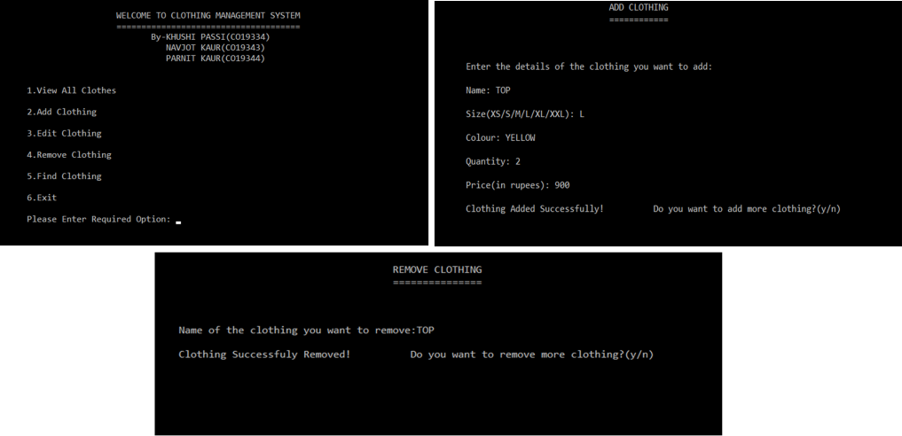

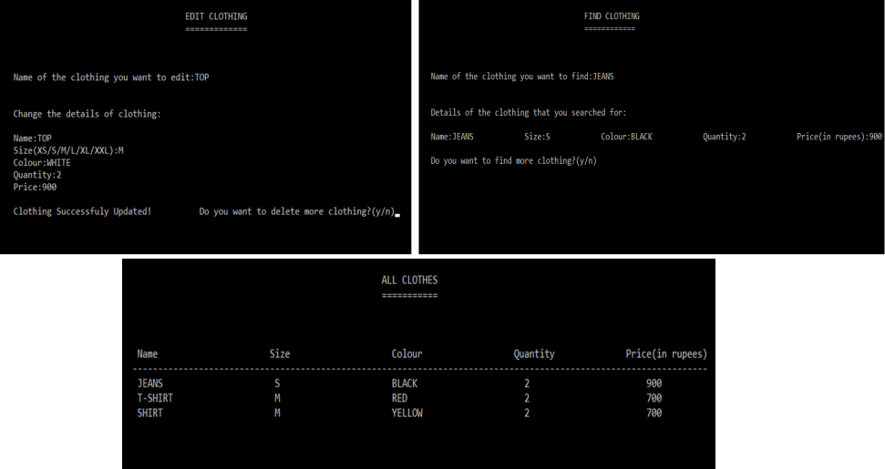

# APPLICATIONS OF THE PROJECT

* The project is designed to help the shopkeeper of a clothing shop or staff at the brand showrooms in a mall to manage their work with ease and to have a proper record of all the clothing items present at their place.
* The project will also help the staff members to know the price of every clothing item, which will help to make the process of billing faster.
* It will also help the staff members to know how many clothes of a particular kind are present which would prevent them for searching for it; hence, will save their time.
* This project can be used at a smaller scale like if a person wants to view the details of the clothes that are present in his wardrobe, he can do this by using this project.

# BIBLIOGRAPHY

We have taken help from the internet and books for making this clothing management system. This includes a lot of major concepts of oops. Our project was made with the help of information and concepts from the following:

**Sites:**

* https://www.tutorialspoint.com/cplusplus/cpp_switch_statement.htm
* https://beginnersbook.com/2017/08/cpp-if-else-statement/
* https://www.geeksforgeeks.org/functions-in-c/
* https://www.geeksforgeeks.org/structures-in-cpp/
* https://www.geeksforgeeks.org/c-classes-and-objects/
* https://www.edureka.co/blog/file-handling-in-cpp/
* https://www.youtube.com/watch?v=CpFx-5J7D7s
* https://codequotient.com/attempt/attempttutorial/5b4de7b29b9f752f53b6e5f6/5b67037a8a85614c456b2289

**Books:**

* Object Oriented Programming with C++ by E Balagurusamy
* Fundamentals Of Computer programming & IT by Sumita Arora

## EXTENSION

This project can be extended for any shop’s product management system just by changing the input details.